

**SCSJ3253: PROGRAMMING TECHNIQUE III**

# **PROJECT TITLE**

# **PLAYER SCOUTING MANAGEMENT SYSTEM**

|  |  |
| --- | --- |
| **GROUP NAME** | **CATCHY** |
| **TEAM MEMBERS** | 1. **MUHAMMAD ZUNNUR BIN MOHD SUHAIMI (SX180425CSJS04)** 2. **MUHAMMAD AKMAL BIN MOHD RAZALI (SX180407CSJS04)** 3. **WAN ATRISYIA BINTI A’ABIDIN (SX180875CSJS04)** 4. **NUR SYAHMIR RAFIQ BIN RAHIM (SX171517CSJF04)** |
| **LECTURER** | **MOHD SHAHIZAN BIN OTHMAN** |

**CONTENT**

1. PROJECT OVERVIEW
   1. TITLE
   2. OBJECTIVE
   3. SCOPE
   4. METHODS
   5. TIMELINE
   6. BUDGET
   7. TEAM
   8. DELIVERABLES
   9. RISK
2. TOOLS AND TECHNOLOGY USAGE
   1. DEVELOPMENT
   2. COLLABORATION
   3. DESIGN
   4. REPORTING
   5. PRESENTATION
3. SYSTEM MODULE
4. MODULE FUNCTIONALITY
   1. LOGIN PAGE
   2. HOMEPAGE
   3. INFO PLAYER
5. DATABASE DESIGN
   1. ENTITY RELATIONSHIP DIAGRAM (ERD)
   2. USE CASE DIAGRAM
   3. ACTIVITY DIAGRAM
   4. AUTHENTICATION
6. REFERENCES

**LIST OF FIGURES**

1. **PROJECT OVERVIEW**

Every students has been assigned to program a project. Theme that were given by lecturer is FIFA World Cup. Hence, it has been decided among groupmates to create a project called Player Scouting System.

FIFA World Cup is the short form of Federation Internationale de Football Association or Soccer’s World Governing Body. It is an international association football boasts 209 member’s, rivalling that of the United Nations, and is arguably the most prestigious sports organization in the world. The tournament will be held every four years since the inaugural tournament in 1930.

Player Scouting System aims to manage player’s statistics along with information in each country that were participated in FIFA World Cup. The information that will be provide by the system is player’s information, tournament matches and information such as goal’s, assist and card’s throughout FIFA World Cup games. It can only be access by management staffs and administrator itself.

This system contains homepage module along with login button’s for administrator and staffs. Administrator and staffs have their own access level. For administrator, they will be able to create and edit player information’s while staffs should only be able to view all the player’s information.

1. **TOOLS AND TECHNOLOGY USAGE**
2. **SYSTEM MODULE**
3. **MODULE FUNCTIONALITY**
   1. **LOGIN PAGE**
   2. **HOMEPAGE**
   3. **INFO PLAYER**
4. **DATABASE DESIGN**

Database Design is the organisation of data according to a database model. The designer determines kind of data that need to be stored and how the data elements tie with one another. Attached database design figure for Player Scouting Management System.

* 1. **ENTITY RELATIONSHIP DIAGRAM (ERD)**

Entity Relationship Diagram or ERD for short form is a graphical representation that depicts relationships among people, objects, places, concepts or events within an information technology system. Attached Entity Relationship Diagram figure for Player Scouting Management System for the whole system including administrator and staffs.

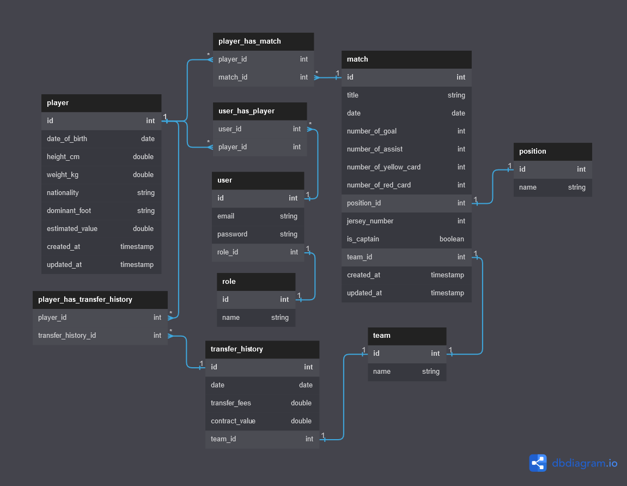

Figure 5.0 Player Scouting Management System Database Design

* 1. **USE CASE DIAGRAM**
  2. **ACTIVITY DIAGRAM**
  3. **AUTHENTICATION**

1. **REFERENCES**
2. <https://en.wikipedia.org/wiki/FIFA_World_Cup>
3. <https://www.ussoccer.com/history/organizational-structure/fifa>